Web Soil Survey HW assignment:

The USDA no longer publishes soil survey data in hard copy. The most recent soil survey information is all online in the USDA’s Web Soil Survey Application. Your HW assignment is to look up your soil under web soil survey and collect information on your soil. There is also an app you can get for your phone called SoilWeb.

- Go to: http://websoilsurvey.sc.egov.usda.gov/App/HomePage.htm
- Click the Green Button: Start WSS
- Search by address, state and county, soil survey area, or GPS coordinates to find your soil location
- Zoom in, or zoom out until the site is viewable in the screen
- Once the site is viewable in the screen, hit the rectangular AOI (area of interest) button and create a red rectangle around your soil
- Now, go to the top of screen and hit the Soil Map Tab
- Click on the soil series (the soil names) to learn more about those soils.
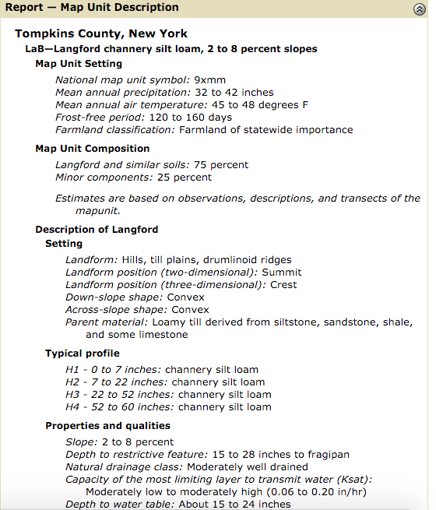
Figure 1: An example of the type of information Web Soil Survey Provides.

- Create a printable version of your map (if you want to save it)
- You can gather more in depth information by going to the soil data explorer tab
- Another option to learn more about your soil series is to go to the Official Soil Series Descriptions Website: https://soilseries.sc.egov.usda.gov/osdname.asp
- After typing in your soil series name, e.g. Langford or Honeoye, there are two options:
- View Description: Gives description of a typical soil by that name
- View Extent Map: Shows the extant of that soil series in the Northeast

Consider gathering the following information:
- Soil Series acronym: e.g. LaB
- Soil name: E.g. Langford Channary Silt Loam
- The Soil Series surrounding your soil
- What type of parent material the soil formed in (Glacial Till, Lacustriane, Outwash Deposit) and other details
- Approximate Slope
- Depth to restrictive feature
- Natural Drainage Class
- Depth to Water Table
- Approximate Texture
- Approximate pH
- ETC. (Looking at the official soil series description will give you more information).

If you want to practice in Web Soil Survey. You can practice with the following GPS coordinates for the Youth Farm Project.

Youth Farm Project Soils in Danby:
42°23'22.77"N, 76°29'31.12"W

MISC. NOTES (Not Important):
L-RV-H: stands for Low-Relative Value-High

